Citizenship, Economics and Society (Secondary 1-3)
“3-minute Concept” Animated Video Clips Series:
“Addiction”
Teaching Guidelines

1. Title of the animated video clip: “Addiction”
2. Duration of the animated video clip: Around 3 minutes
3. Related CES Module: Module 2.1 Overcoming Growth Challenges
4. Introduction of the animated video clip: The animated video clip was developed by the Personal, Social and Humanities Education Section, Curriculum Development Institute, Education Bureau. It uses daily examples and simple language to succinctly explain the concept of “Addiction”.
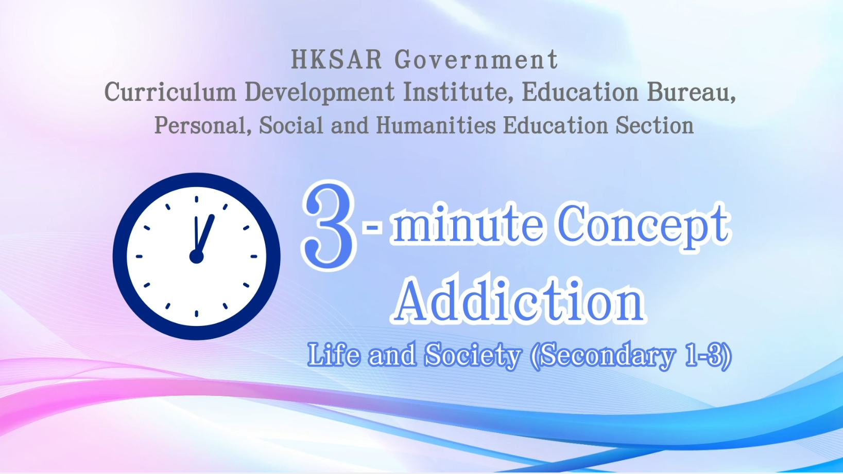
Citizenship, Economics and Society (Secondary 1-3)
Video link: https://emm.edcity.hk/media/Citizenship%2C+Economics+and+Society+%223-minute+Concept%22+Animated+Video+Clips+SeriesA+%2814%29+Addiction+%28English+subtitles+available%29/1_jimgej5n
5. Teaching tips: Teachers must explain the following main points to students after playing the “Addiction” animated video clip:
1) Developing a healthy lifestyle is important for preventing addictive behaviours | Teachers should point out to students that developing a healthy lifestyle is important for adolescents’ development. Adolescents should develop positive values and self-management skills to overcome growth challenges, and reject and stay away from undesirable behaviours. Teachers can advise students to participate in healthy group activities, sports activities, and community services, to live a fulfilling life with optimism, perseverance, proactiveness and positive beliefs and to avoid addictive behaviours.
2) Principles and ways to cope with peer pressure or conformity pressure | Teachers should point out to students that peer pressure or conformity pressure is one of the major causes of addictive behaviours in adolescents. Some adolescents mistakenly believe that they can gain the recognition of others by conforming to their expectations. They then unconsciously develop addictive behaviours such as smoking, gambling, and even taking drugs. Teachers should further point out to students that when facing peer pressure or conformity pressure, they should exercise critical thinking and uphold the principle of law abidingness and rationally reject undesirable behaviours. If necessary, they should leave the scene and seek assistance from teachers. Teachers are suggested to refer to the following resource:  廉政公署社區發展處– 廉政公署德育期刊–朋輩正能量  (Chinese version only)  https://me.icac.hk/filemanager/common/bookshelf/topsee/64/62.pdf
3) Characteristics of Internet addiction and ways to prevent it | Teachers should point out to students that with the prevalence of the Internet, online games, social media and online shopping sites are becoming increasingly popular. Many adolescents who are not psychologically and mentally mature have become addicted to the cyber world due to a lack of self-control, resulting in plummeting academic performance and disengagement from normal social circle to become hidden youths. Teachers should further point out to students that proper Internet use can bring convenience and enhance the enjoyment of our daily lives. Adolescents should develop good Internet habits, such as limiting the hours they spend online each day and completing their homework or work before going online, and avoid Internet addiction. Teachers can refer to the following resource:  Centre for Health Protection - Trapped in the Net  https://www.chp.gov.hk/files/pdf/ncd_watch_jul2013.pdf
4) Possible consequences of addictive behaviours | Teachers should point out to students that all addictive behaviours can cause different degrees of harm to the individuals involved, their families, friends and society. For example, gambling addiction can lead to bankruptcy resulting in one’s dependence on borrowing to support living expenses; while alcohol and tobacco addiction can damage health and increase cancer risk. Teachers can further point out to students that some addictive behaviours, such as taking drugs, may involve criminal offences and lead to imprisonment and ruining one’s future. Teachers can refer to the following resource:  Hong Kong Police Force - Friendship Forever  https://www.police.gov.hk/info/pr/ycpb/

6. Consolidation questions : (See next page)

“3-minute Concept” Animated Video Clips Series:

“Addiction”

Worksheet

A. Fill-in-the-blank Question
Write the types of addiction in the following table, give two examples for each type of addictive behaviours and list the adverse effects of the addictive behaviours.
Addiction | Types | Examples | Adverse effects
 | Substance addictions | - Drug  - Alcohol  - Tobacco  (Any two items) | Physiological effects  - Addiction can cause a lot of harm to the body. For example, people who consume cigarette, drugs or alcohol are more likely to develop lung or liver cancer. Drug addicts who share syringes are more likely to get AIDS.  - People who are addicted to the Internet or gambling often have nights and days flipped upside down and suffer from lack of exercise which can lead to poor nutrition, sleep deprivation or weakening of immunity. Internet addictions can lead to other physical illnesses, such as eyestrain and joint strains.  Mental effects  - Addicts tend to get low moods, feel depressed and irritated easily, or even more likely to act aggressively.  - Addictions can cause alienated interpersonal relationships, may also lead to family disputes, broken friendships and affect school performance.  - Some addicts may even commit crimes to get money to support their addictive behaviours. There are criminal liabilities, and criminal convictions will ruin their lives and future.
 | Behavioural addictions | - Gambling  - Shopping  - Internet  - Computer gaming  (Any two items)

B. True of False
Study the following sentences about the causes of addictive behaviours. Put a “T” in the blank for correct description and an “F” for incorrect description.
 | When there are conflicts among family members, some young people may escape by turning to addictive substances or addictive behaviours. | T
 | Young people who have friends with addictions may engage in addictive behaviours due to peer pressure or the need to win their acceptance. | T
 | It is more common for young people who are strong in self-control, resilience or problem-solving skills to resort to addictive substances or behaviours to relieve pressure and escape from reality. | F

C. Short Question
What should one do if one has acquired an addictive behaviour?
Depending on the types of addiction, different measures shall be
adopted:
- For substance addiction, for example, drug taking, alcoholism¸
medicines which pinpoint the medical and psychological needs are
used to help get rid of the addiction, with the inclusion of
psychological therapy, family counselling, etc. as support
measures.
- To improve interpersonal relationships and to learn skills to refuse
addictions by joining healthy group activities , sports activities and
community services.
- To seek help, for example, from related government or non-
governmental organisations, social workers, teachers, etc.

The End

